Data Engineering Pipeline
How stored data is transformed into a personalized LLM response
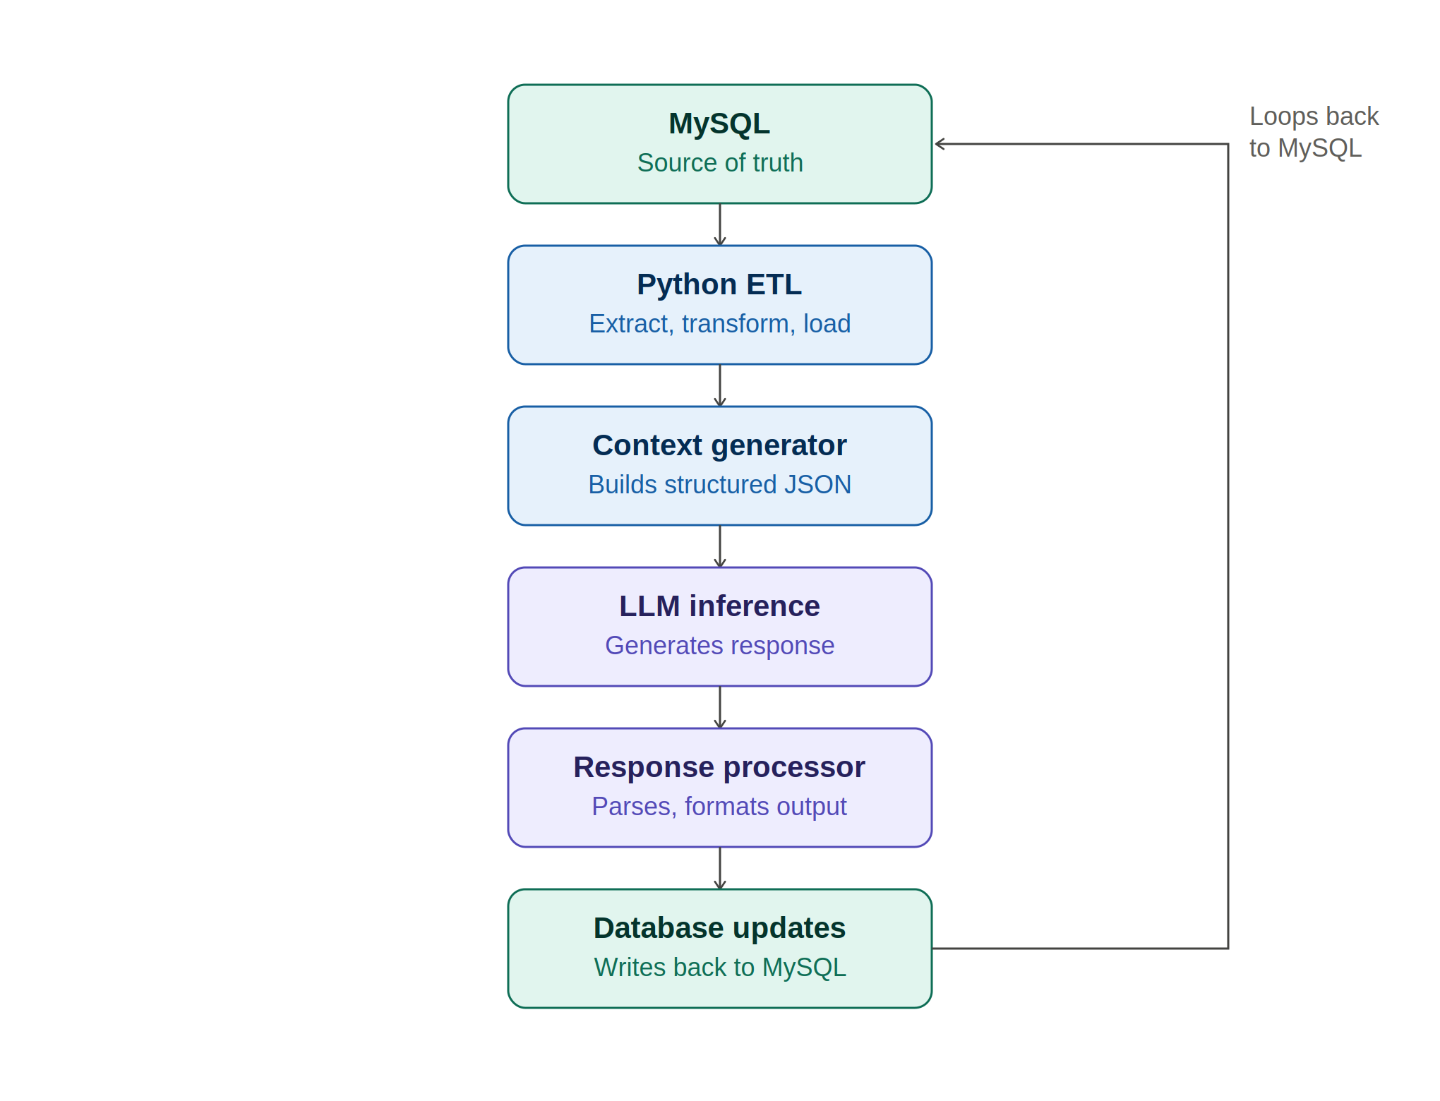

Pipeline Stages
MySQL | Persistent store holding user data, profiles, and notebook content — the source of truth for the pipeline.
Python ETL | Extracts raw records from MySQL, transforms them into a clean structure, and loads them for downstream use.
Context generator | Builds a structured JSON context object from the transformed data, ready to be sent to the LLM.
LLM inference | Sends the prepared context to the LLM API, which generates a personalized response.
Response processor | Parses and formats the LLM's raw output into a usable response for the application.
Database updates | Writes relevant results and state back into MySQL, closing the loop for the next cycle.

